Lab experiment

1.Create a new process by invoking the appropriate system call. Get the process identifier of the currently running process and its respective parent using system calls and display the same using a C program.

Aim:
To create a new process using the fork() system call and obtain the process ID (PID) and parent process ID (PPID) using getpid() and getppid() system calls.

Algorithm:
- Include necessary headers: Include the necessary header files like <stdio.h> and <unistd.h> for using system calls.
- Declare variables: Declare variables to hold the process ID (pid_t pid)and the parent process ID (pid_t ppid).
- Get the current process ID: Use the getpid() system call to retrieve theprocess ID of the current process.
- Get the parent process ID: Use the getppid() system call to retrieve theparent process ID.
- Display the process IDs: Print the process IDs to the console.
- Create a new process: Use the fork() system call to create a new process. Check the return value of fork() to determine whether the code is running in the parent or child process.
- Display process IDs in child and parent processes: Depending on whether the process is the parent or the child, display the respective processIDs.

Coding:
#include <stdio.h>
#include <unistd.h>
#include <sys/types.h>
#include <sys/wait.h>

int main()
{
pid_t pid;

pid = fork();
if (pid < 0)
{
printf("Process creation failed\n");
return 1;
}
else if (pid == 0)
{
printf("Child process\n"); printf("Process ID (PID): %d\n", getpid());
printf("Parent process ID (PPID): %d\n", getppid());
} else
{
wait(NULL); printf("Parent process\n"); printf("Process ID (PID): %d\n", getpid()); printf("Parent process ID (PPID): %d\n", getppid()); printf("Child process ID: %d\n", pid);
}

return 0;
}

Output:

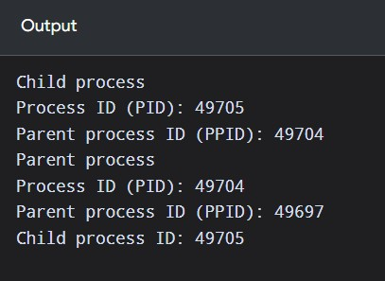

Result:
Thus, a new process was created using the fork() system call, and the process ID and parent process ID were obtained and displayed using getpid() and getppid().

